Part A
Title: Demonstrate continuous integration and development using Jenkins
- Objective: Implement continuous integration using Jenkins.
- Tasks:
  - Manage plugins: To install plugins for integration with Jenkins.
  - Global Tool Configuration: To Configure plugins for integration with Jenkins
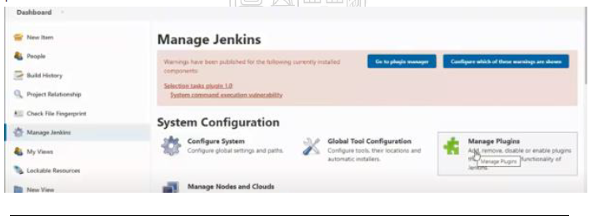

1. Install any Java/Python compiler on the computer and set path
Python Programming
2. Create a python program and run/check on cmd [program without user input]
3. Create Jenkins->new view-> expt4
4. Install Python plugins from Jenkins->Manage Jenkins->Manage plugins->python
5. Restart Jenkins
a. Windows: run->systemctl.msc->Jenkinns->restart
b. Ubuntu command: systemctl Jenkinns restart
6. Configure Jenkins->Manage Jenkins->global tool configuration->python

Programming
a. Implicit: writing code inside the Jenkins
i. Create New item-> freestyle project->build tab, write python script and build
b. Explicit: writing code outside the Jenkins
i. Create New item-> freestyle project>build tab, write window batch command and build

Java parametrized Programming [Explicit only]
- Create New item-> freestyle project this project is parametrized
- Set two string parameter num1 and num2
- Select build tab->window batch command, write command and build
Reference
1. https://www.tutorialspoint.com/jenkins/index.htm
2. https://www.guru99.com/create-builds-jenkins-freestyle-project.htmlhtml
3. Effective DevOps: Building a Culture of Collaboration, Affinity, and Tooling at Scale, Jennifer Davis, Ryn Daniels, O'Reilly Media June 2016.

Part B

(PART B : TO BE COMPLETED BY STUDENTS)
(Students must submit the soft copy as per following segments within two hours of the practical.)

Roll No. | Name:
Class: B Tech AI | Batch:
Date of Experiment: | Date of Submission:
Grade:

Document with screenshots
1. All steps to install python plugin and configuration.
2. All steps to execute Implicit and Explicit python program.
3. All steps to execute Explicit java parametrized program.

